Project Scoping Document

Name: Example 1

## Business Problem:

The Real Estate market has been on a constant rise worldwide. You are tasked by your project manager to investigate residential properties in Connecticut and see how the property value has changed over the last 2 decades. Using this dataset, find out property assessment value vs what the property is sold for. The objective is to find out how the Real Estate market changes overtime in Connecticut. With this dataset, you can use the data on the characteristics of each property, to estimate what a hypothetical property might be assessed at, and what a property might sell for.

## Business Impact:

Exploring this data could allow the company to make better decisions in regards to investment properties. It could also allow for more accurate valuations through predictive analytics. This can help sellers know how to accurately price their properties, and it could help buyers know whether the home will meet the appraisal. Analysis could also view trends and assess market forces leading to a rise or dip in property prices.

## Dataset(s):

Connecticut Real Estate Data

**Strengths:** data contains over 900k rows and measures 20 years  
**Weaknesses:** lacking in specifics regarding characteristics of each house, such as size, build year, rooms. Some values are incorrect, data needs some cleaning.

Possibly adding additional datasets on housing sales to investigate how property characteristics influence

## Methods:

➢ Variables and comparisons

➢ Expecting relationships between:

○ Date and assessed value

○ Date and sale amount

○ Town and price

○ Assessed value and sale amount

○ Residence type and price

○ Could use a mapping feature and index proximity to water

○ Property type and sale amount

○ Property type and assessed value

## Dashboard

The dashboard will give various metrics, as well as showing the overall price trend and list the factors involved in the trend.

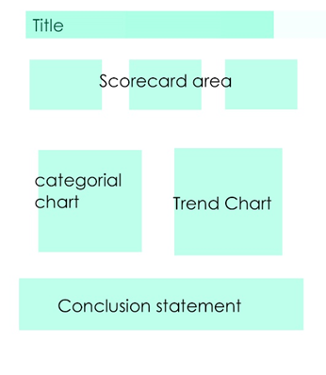

## Milestones

* Identify characteristics of variables
* Find additional datasets
* Clean data
* Create visualizations
* Show relationships between variables
* Create dashboard
* Write final report

## Timeline

| Week | Tasks |
| --- | --- |
| Week 1 | Explore initial dataset, and find additional datasets (if needed)  Clean data  Identify characteristics of variables  Envision final product  Feature Engineering |
| Week 2 | Create visualizations  Show relationships between variables  Tabulation and Pivot Tables |
| Week 3 | Create dashboard  Write final report |

Add additional weeks as necessary.